MATERIASL

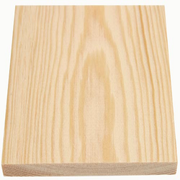**Pine Wood**

**The wood i am going to be using is pine wood. It is softwood that is easy to cut and is very light weight, it is not as expensive as compare to the other woods. It has a natural colour that blends in with other furniture.**

**Aluminium**

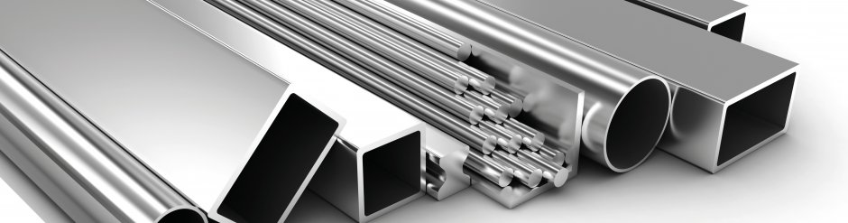**I will use Aluminium and Aluminium as a metal is highly durable and lightweight and it is resistant towards rust and it can be easily cleaned it is impervious to stains and resistant to many types of chemicals.**

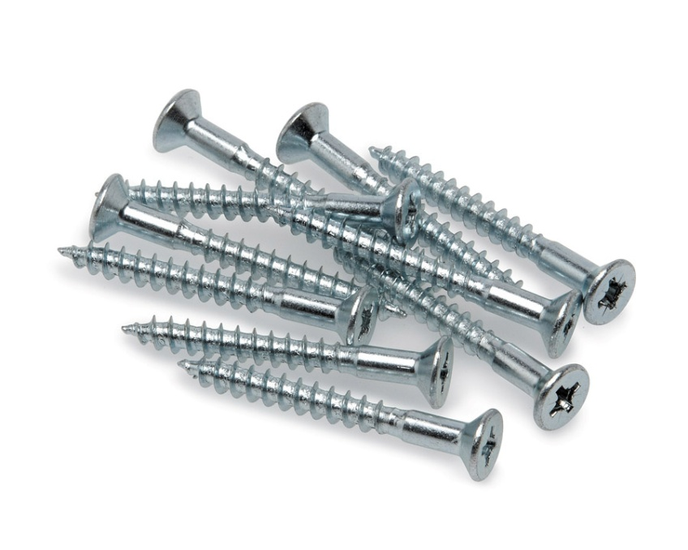**Screw**

**I will need to use screws as this will help me to keep the wood intact with each other.They are not very expensive and it is better then using an adhesive to keep them intact since adhesive can have many factors such as heat.**